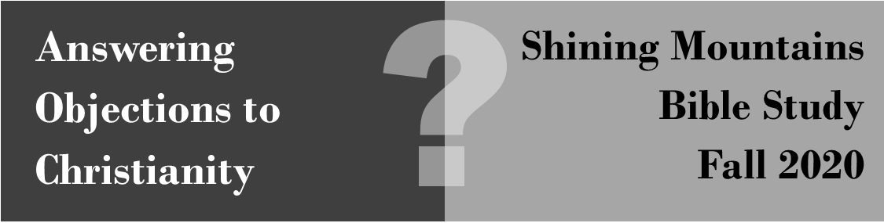

“With so many denominations and interpretations of the Bible, how do you know that you are right?
If Christianity is true, why isn’t there just one Christian religion?”

Introduction
Bobby Conway, the speaker for the One Minute Apologist, states, “Many of these denominations have been created over our own human pettiness.” What’s your reaction to his answer? (Click here to watch the video https://www.youtube.com/watch?v=mh0j-rIwTjc)

Personal Questions
Create a list of problematic passages or doctrines that seem to be simply a matter of personal interpretation. (Be honest, I won’t make you share, unless you want to.)

Agree / Disagree & why: “The Bible is a confusing book to read and understand on my own.”

Approaches to Theology
Deuteronomy 4:2 “Do not add to what I command you and do not subtract from it.”

Read the following primary source quotes in light of the Bible passage above.

- Determine what is their source(s) of theology.
- Explain why this is a fundamental insight into why there are so many different denominations.

- Herbert Chilstrom, in The Lutheran, March 21, 2984: “The prescriptive method [of using Scripture] is based on the assumption that Scripture is used to discover final answers to questions. Thus, when confronted with a particularly thorny issue, one could go to Scripture, study carefully every text that addresses the issue and come up with a conclusive response. Scripture as “norm” means Scripture as answer book. I suspect that most of us in the LCA come at these matters from the descriptive method. We see Scripture as no less important. ... But for us “norm” means “guide” rather than “rule” [= ‘standard’]. Having informed ourselves of what Scripture has to say, we go on to ask questions about other ways in which God may be trying to enlighten us.”
- Clark Pinnock, Most Moved Mover, p. 19-23, “[I] consult a quadrilateral of sources in the attempt to be bi-polar: the Bible, tradition, reason, and experience. To be more precise, I adhere to the rule of Scripture within a trilateral hermeneutic…. I hold the Bible to be the primary norm for theology in the midst of the other sources…. Moving to the second source, tradition is important, because theology ought not to be biblical in an isolated way. Scripture may be prima [first], but it is not sola [alone] because tradition plays a role in interpretation…Third, reason has a role to play in theology; and helping us say what we want to say. Serious theologians value coherence and intelligibility in their work….Fourth, with respect to experience, theology should be concerned about existential fit and practical adequacy of a theological model to meet the demands of life.”
- Carl Braaten, Christian Dogmatics, I, p. 61, 74ff, “The ultimate authority of Christian theology is not the biblical canon as such, but the gospel of Jesus Christ to which the Scriptures bear witness—the ‘canon within the canon.’ … Biblicism holds to an infallible Bible that can be the absolute authority in matters of belief and morals. …Fundamentalist biblicism is rejected by most theologians and is out of favor in most of the seminaries that train clergy for the parish ministry. They reject biblicism not merely because historical science has disclosed errors and contradictions in the biblical writings, but rather because the authority of the Bible is elevated at the expense of the authority of Christ and his gospel.”
- Daniel Clendenin, Eastern Orthodox Christianity: A Western Perspective, p. 104-105, “It is the Orthodox view that the Christian faith and experience can in no way be compatible with the notion of ‘Sola Scriptura,’ and the explicit rejection of all authority except Scripture. The Bible is not a thing-in-itself that can be isolated or separated from the context of the church and tradition. …It is precisely this view of the self-sufficiency of Scripture, elevated above the church, that Orthodoxy considers to be what Florovsky calls ‘the sin of the Reformation,’ the consequences of which are arbitrary, subjective, and individualistic interpretations of the gospel.”
- Paul Tillich, Systematic Theology, 1, p. 51, “Experience as the inspiring presence of the Spirit is the ultimate source of theology.”
Hermeneutics: The Study of Interpreting the Bible
Moses Silva is a New Testament scholar & Bible translator who states, “the principle of contextual interpretation is, at least in theory, one of the few universally accepted hermeneutical guidelines.” (Biblical Words & Their Meaning: An Introduction to Lexical Semantics) In other words, the bottom line of biblical interpretation is reading a passage in its context and understanding the genre it is. We let the Bible speak for itself and interpret itself.

The Principle in Real Life!
Explain how you know if your friend is joking with you, being sarcastic with you, or actually cutting you down.

Put into Practice
Explain how the following teachings misunderstand the original context.

- The six days refer to a long, indefinite time period in which God used the process of macroevolution to create the world.
Exodus 20:9-11 - Six days you shall labor and do all your work, 10 but the seventh day is a sabbath to the LORD your God. On it you shall not do any work, neither you, nor your son or daughter, nor your male or female servant, nor your animals, nor any foreigner residing in your towns. 11 For in six days the LORD made the heavens and the earth, the sea, and all that is in them, but he rested on the seventh day. Therefore the LORD blessed the Sabbath day and made it holy.

- In Revelation, Jesus will come back to set up a physical 1000 year reign on earth.

Revelation 20:1-2 - And I saw an angel coming down out of heaven, having the key to the Abyss and holding in his hand a great chain. 2 He seized the dragon, that ancient serpent, who is the devil, or Satan, and bound him for a thousand years.

- The bread and wine in the Lord’s Supper symbolize or represent Jesus’ body and blood.

1 Corinthians 11:23-28 - For I received from the Lord what I also passed on to you: The Lord Jesus, on the night he was betrayed, took bread, 24 and when he had given thanks, he broke it and said, “This is my body, which is for you; do this in remembrance of me.” 25 In the same way, after supper he took the cup, saying, “This cup is the new covenant in my blood; do this, whenever you drink it, in remembrance of me.” 26 For whenever you eat this bread and drink this cup, you proclaim the Lord’s death until he comes. 27 So then, whoever eats the bread or drinks the cup of the Lord in an unworthy manner will be guilty of sinning against the body and blood of the Lord. 28 Everyone ought to examine themselves before they eat of the bread and drink from the cup.

Church Fellowship
Romans 16:17 - I urge you, brothers and sisters, to watch out for those who cause divisions and put obstacles in your way that are contrary to the teaching you have learned. Keep away from them.

“Fundamentalism,” technically speaking, believes that certain key doctrines of the Bible are necessary (fundamental) for churches to unite (e.g. the inspiration of Scripture, the Trinity, the deity of Christ), while other doctrines are not as important (e.g. baptism, Lord’s Supper, creation).

- How does this passage’s description of the Bible contrast with that view?

- What are some practical problems with the approach, “Churches should just agree to disagree on minor teachings?”

Conclusion
Practice how you would answer the above objection to Christianity.

Chilstom became the first bishop of the Evangelical Lutheran Church of America (ELCA)
Originally a Baptist, Pinnock shifted to open theism, that is, God changes along with the world.
Carl Braaten was a professor in the ELCA at the Lutheran School of Theology in Chicago.
Tillich is a twentieth-century theologian and philosopher famous for his existentialism.

